Technical aspects, interpretation of data and clinical application of esophageal high-resolution manometry
V.O. Kaibysheva¹, Albert J. Bredenoord², A.A. Smirnov³, E.D. Fedorov¹, E.L. Nikonov¹
¹Pirogov Russian National Research Medical University
²Academic Medical Center
³ Pavlov St Petersburg State Medical University
Aim. To describe the esophageal high-resolution manometry (HRM) performance and interpretation based on international guidelines. To present the significance of the HRM in the clinical evaluation of patients with esophageal symptoms, especially dysphagia, and choosing a treatment option in patients with esophageal disorders.

Summary. Disordered esophageal motor function can be an underlying cause of many esophageal disorders. HRM allows the most accurate measurement of the upper and lower esophageal sphincters resting pressure (LES, UES), LES and UES relaxation during swallowing, a vigor of esophageal contractions, a position of upper and lower esophageal sphincters (a distance from nostrils), and a length of the esophagus. The esophageal manometry helps to identify the hiatal hernia (HH) and its dimensions, spastic contractions and ineffective esophageal motility, and any obstacle to a bolus passing through the sphincters. The evaluation of changes in esophageal motility is essential in differential diagnosis in patients with dysphagia or non-cardiac chest pain, for decisions towards endoscopic or surgical treatment of the gastroesophageal reflux disease (GERD), achalasia, and other disorders of the esophagus.
Conclusion. The esophageal manometry is recommended for the evaluation of patients with nonobstructive dysphagia, noncardiac chest pain, regurgitation, and eructation. The evaluation of esophageal motility is paramount at making a final decision towards possible and required surgical treatment of GERD and achalasia. At present, the esophageal high-resolution manometry is the gold standard in diagnosis of esophageal motility disorders.
Keywords: high-resolution manometry, achalasia, gastroesophageal reflux disease, fundoplication.
There is no conflict of interests.

Introduction
Esophageal motility disorders can be an underlying mechanism of the pathogenesis of many esophageal disorders, such as gastroesophageal reflux disease (GERD), achalasia. In other diseases (scleroderma systematica, eosinophilic esophagitis), the motility disorders are consequences of structural changes in the esophageal wall and LES.
The potential of this modern and high-tech tool includes measurement of the upper and lower esophageal sphincters resting pressure (LES, UES), LES and UES relaxation during swallowing, a vigor of esophageal contractions, a position of upper and lower esophageal sphincters (a distance from nostrils), and a length of the esophagus. The esophageal manometry helps to identify the hiatal hernia (HH) and its exact dimensions, premature (spastic) contractions or ineffective contractions of the esophageal body and any obstacle for a bolus passing through sphincters [1].
The esophageal manometry is indicated in patients with such clinical symptoms as dysphagia, noncardiac chest pain, regurgitation, etc. The evaluation of esophageal motility is paramount at making a decision towards possible and required surgical treatment of GERD and achalasia.

History of the method
The esophageal motor function studies (a so-called conventional manometry) were first performed as early as in 1940s-1950s using an intraesophageal balloon filled with water or gas introduced into the lumen of the organ. However, this procedure had significant restrictions due to an extremely slow response and low sensitivity of the registering system to changes in the intraesophageal pressure, as well as due to the effect of the balloon on esophageal motility. In 1970s, W. Dodds and R. Arndorfer developed a brand new system for esophageal pressure measurement: water-perfused manometry with a catheter consisting of the capillary tubes system fed with water by an external pump [2, 3]. The advantages of the water-perfused manometry included a significantly higher sensitivity (as compared to the balloon) and registration of peristalsis at several points along the esophagus. The disadvantages included a small number of channels in the catheter located distant from each other (not less than 5 cm), as well as the method laboriousness and a low accuracy of the findings obtained for pressure measurement in the LES area due to a proximal dislocation of the sphincter associated with peristaltic wave after swallowing.
In 1977, the Dent sleeve sensor catheter was introduced, in which a 6-cm sleeve sensor was added to continuously measure the LES pressure [4]. The sleeve eliminated the LES dislocation and carry out more exact measurements shown on the screen as several two-dimensional curves (Y-axis: pressure; X-axis: time). The curve analysis allowed evaluation of the resting LES pressure and residual LES pressure, and the amplitude of contractions of the thoracic esophagus; diagnosis of spastic contractions and no contractions in the body of the esophagus during swallowing [1, 4].
Attempts to optimize the test methods for esophageal motility disorders were also made in Russia. In 1970-1980-s, V.Kh. Vasilenko and A.L. Grebenev used a probe with several small-diameter balloons thus avoiding an excessive stimulation of the esophagus and secondary contractions of its wall [5].
S.A. Chernyakevich contributed greatly to the development of esophageal functional diagnostic techniques in this country; she developed a brand new test method, ionomanometry, using a combined specific probe (Istok-system, Fryazino) which contained two open manometric catheters in addition to pH sensors. The distance between the catheters was 5 cm. The method technique was to introduce a probe from the stomach into the esophagus at a 1-0.5 cm interval and record pressure changes in different parts of the esophagus. A combination of pH-metry and manometry within a single study permitted to identify esophageal motility disorders, structural abnormalities of the LES (axial hiatal hernia) and gastroesophageal reflux at the same time [5, 6].
In 1990-s, Ray Clouse et al. developed a new system for pressure measurements characterized by a reduced distance between sensors (from 3-5 to 1 cm) and an increased number of sensors on the catheter from the pharynx to the esophagus (up to 36). This approach facilitated simultaneous evaluation of the upper esophageal sphincter, esophageal and LES motor function all together [7]. An addition of one more axis became a significant improvement of the procedure; it evaluated pressure changes in topography instead of a conventional two-dimensional plane (Y-axis: contraction vigor, X-axis: time). The topographic approach to data presentation when higher pressure values are depicted in colours of the red-brown spectrum and lower pressure values are depicted in blue resulted in a pictorial and easy for the analysis and interpretation presentation of the esophageal contractile function (Figure 1) [8].

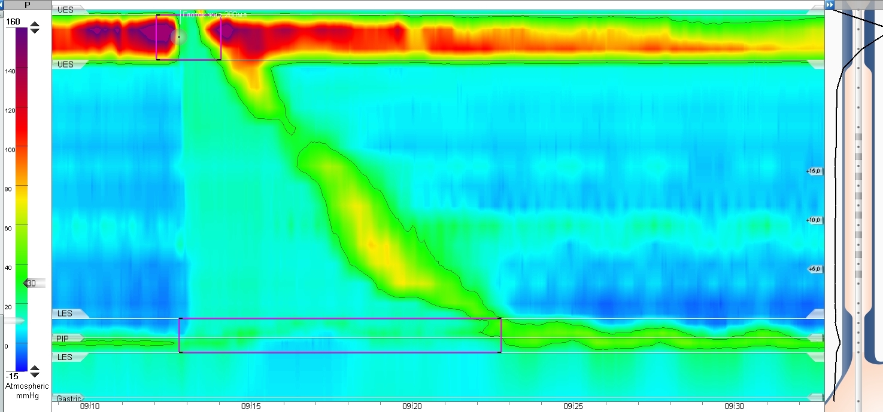
Figure 1. High-resolution manometry: normal esophageal motility

The main advantages of the high-resolution manometry are accurate calculations, a simple procedure, and an illustrative method. During the study, the software synthesizes an integral picture of the esophageal motility so that a real-time 3D image of the esophageal functional anatomy is shown on the screen.
In order to standardize the test procedure, data analysis, and systematization of nosologies, the 2008 San Diego (USA) consensus of experts in esophageal manometry generated the Classification of Esophageal Motility Disorders. Later, such consensuses were held in Ascona (Switzerland) in 2011 and in Chicago (USA) in 2014. Results of the recent consensus The Chicago Classification of Esophageal Motility Disorders, v3.0 were published in the Neurogastroenterology and Motility journal in 2015 [9].
In the Russian Federation, the task force and the Review Board on methodology and terminology of the high-resolution manometry first met on November 11, 2017 (St. Petersburg) at the research-to-practice conference 2017 Modern Aspects of Diagnosis and Treatment of Benign Esophageal Disorders. The Review Board hence adopted the general procedure for the esophageal manometry and the accepted Russian terminology published as The First Russian Consensus in the High-Resolution Esophageal Manometry in the Evidence-Based Gastroenterology journal.
Main indications and contraindications for the esophageal manometry, as well as stages of the high-resolution esophageal manometry interpretation in accordance with the current Chicago Classification of Esophageal Motility Disorders are listed below [9, 10, 11].
The esophageal high-resolution manometry is indicated:
- in dysphagia after ruling out the organic obstruction: diagnosis of distal esophageal spasm, achalasia, and ineffective esophageal motility;
- in non-cardiac chest pain: diagnosis of distal esophageal spasm, hypercontractile esophagus, achalasia, HH;
- in preoperative examination of patients with achalasia (to confirm the diagnosis and specify the achalasia type);
- in preoperative examination of GERD patients in whom anti-reflux surgery is scheduled (to rule out the ineffective esophageal motility and achalasia and to specify the HH dimensions);
- in preoperative examination of patients with obesity in whom bariatric surgery is scheduled;
- to control the surgical treatment efficacy of achalasia and GERD;
- to determine the LES position before the pH-metry or impedance pH-metry;
- in dysphagia after anti-reflux surgery;
- to determine exact dimensions of the HH.

The esophageal manometry is not performed in cases, when any invasive probe diagnostic manipulations are contraindicated:
- esophageal and gastric malignancies;
- esophageal and gastric ulcers with a risk of bleeding;
- II-IV degree esophageal varices;
- recent (less than 3 months) surgical interventions or bleeding from the upper gastrointestinal tract;
- burns, diverticula, decompensated esophageal strictures;
- persistent cough or vomiting;
- aortic aneurysm;
- severe essential hypertension;
- obstruction of the nasopharynx;
- maxillofacial trauma;
- severe coagulopathies;
- mental disorders.

The high-resolution esophageal manometry include the following stages:
- Preparation for the study; catheter calibration (for the water-perfused system);
- Introduction of a catheter into the esophagus and its placement at a required depth;
- Per protocol study according to the Chicago Classification;
- Interpretation of results;
- Drawing a conclusion.

High-Resolution Manometry Study
The esophageal motility study is performed in the supine position (in order to exclude the effect of the gravity force on the fluid pressure in capillaries of a water-perfused catheter and on the esophageal motility) with assessment of the LES resting pressure and peristalsis of the esophageal body after administering ten 5 mL water swallows (according to the Chicago Classification ). The interval between swallows should be not less than 30 seconds [9].
After catheter calibration and the application of a topical anesthetic to the patient’s naris and/or throat, the HRM catheter is placed transnasally and positioned with the pressure sensors spanning a length extending from the hypopharynx, through the esophagus, to 3 to 5 cm within the stomach. After a brief period to allow patient acclimation, a baseline of resting pressures can be obtained during approximately 30 seconds of easy breathing without swallows. Correct catheter placement to traverse the esophagogastric junction can be confirmed during this period by recognition of the presence of the pressure inversion point, which is the point at which the inspiration-associated negative intrathoracic pressure inverts to the positive intra-abdominal pressure. Having the patient take deep breaths facilitates identification of the pressure inversion point by augmenting the EGJ pressure and exaggerating the intrathoracic and intra-abdominal pressures[10].
In addition to the standard protocol, many investigators assume further diagnostic tests (outside the Chicago Classification) such as solid food swallowing (boiled rice, dry cracker) and multiple rapid swallow test (5 swallows of 2 mL of fluid each at a 2-3 s interval) to assess latent disorders and the spare capacity of the esophageal motor function more properly [11, 12, 13, 14, 15,16].

Interpretation of Esophageal Pressure Topography
HRM studies can be interpreted in a stepwise, hierarchical fashion directed by the Chicago Classification. The evaluation scheme is intended only for patients without prior surgery affecting the esophagus or the esophagogastric junction [9]. It is important that the absolute values reported in the Chicago Classification are based on normative values generated with the Sierra HRM assembly (Given Imaging) from supine swallows of 5 mL of water. Thus, the interpretation of manometry studies performed using different catheter assemblies, patient positions, and/or boluses (volume and/or consistency) requires the recognition of expected differences in the normative values of HRM metrics [10]. The evaluation scheme is consist of Esophagogastric Junction resting pressure and Individual Swallow Assessment.
Although not incorporated in the Chicago Classification of esophageal motility diagnoses, esophago-gastric junction (EGJ) morphology and basal pressure should be assessed with HRM. The basal EGJ pressure should be assessed during a period of quiet breathing without swallows [10].
At rest, (“resting” landmark recording is measured during an episode in which the patient does not swallow and breathe normally) 2 high-pressure areas are distinguished in contour plots; the Chicago Classification call these areas the resting pressure. In addition, pressure changes in functionally different parts of the esophagus related to pressure changes in the thoracic and abdominal cavities may be observed depending on the respiration phase (Figure 2):
- at inspiration, the pressure in the thoracic cavity decreases (negative pressure), the EGJ is dislocated towards the stomach due to contraction of diaphragm crura; at that, the pressure in the esophago-gastric junction increases [10];
- at expiration, the pressure in the thoracic cavity is increased, and the EGJ area is shifted proximad.

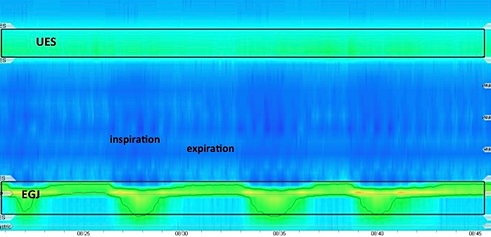
Figure 2. Resting pressure

The analysis of contour plots at rest include the assessment of the following parameters:
- EGJ tone (basal pressure, resting pressure) during expiration and inspiration;
- EGJ morphology.

The following changes in the EGJ resting pressure may be found during the study:
- A decrease in the EGJ tone (Figure 3). As a rule, these changes are typical for patients with GERD or systemic diseases of the connective tissue and diabetes mellitus [11];
- An increase in the EGJ tone above. It is most common among patients with achalasia and hypercontractile esophagus (Figure 4).

Figure 3: A decrease in the EGJ tone

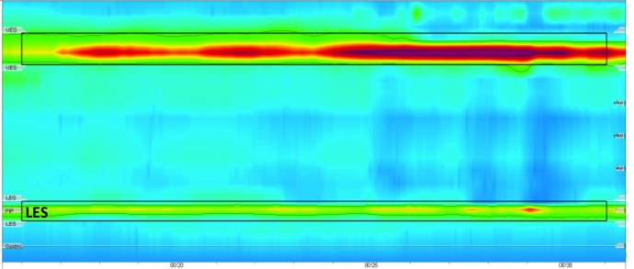
Figure 4: An increase in the EGJ tone
With HRM and Clouse plots, the relative localization of the two contractile elements of the EGJ, the LES and the crural diaphragm (CD) can be distinguished. According the Chicago Classification there are three types of EGJ morphology [9]:
- Type 1 (normal): Complete overlap of CD and LES components with single peak on the spatial pressure variation plot (Figure 5);
- Type 2 (within normal): LES and CD are spatially separated such that there is a double-peaked pressure profile on the spatial pressure variation plot at inspiration, but the nadir pressure between peaks does not decline to gastric pressure and the separation between the LES and CD peaks is 1–2 cm (Figure 6);
- Type 3 (hiatal hernia): the inspiratory spatial pressure variation plot exhibits >2 cm separation between the LES and CD peaks with the nadir pressure between them equal to or less than gastric pressure (Figure 7).

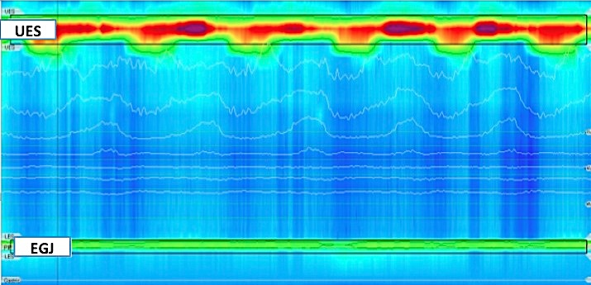
Figure 5. Morphology of the esophago-gastric junction: type 1

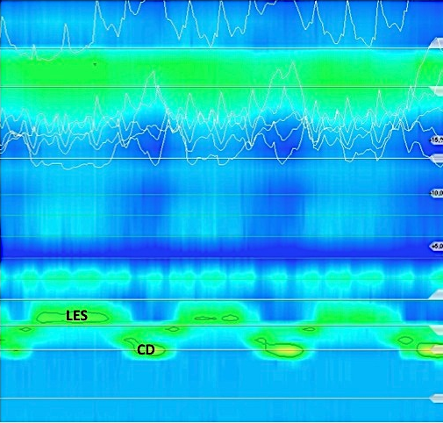
Figure 6. Morphology of the esophago-gastric junction: type 2
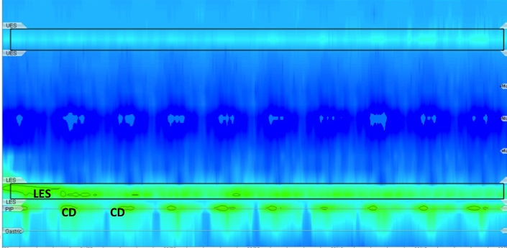
Figure 7. Morphology of the esophago-gastric junction: type 3

After evaluation basal EGJ, esophageal motility is examined in Individual Swallow Assessment. The esophageal manometry evaluates the deglutitive LES relaxation and esophageal body contractility and/or peristalsis during each swallow.
The analysis of each swallow starting with assessment of the LES relaxation using a specific integral parameter, integrated relaxation pressure (IRP). IRP is the mean pressure of the EGJ during the 4 contiguous or noncontiguous seconds of maximal relaxation (ie, lowest pressure) in the deglutitive window (10 seconds after the swallow). IRP is dependent from gastric pressure, therefore, it is better to place the gastric reference 2 cm below the EGJ. Normal IRP usually does not exceed 15 mmHg [9]. The increased IRP demonstrates a functional (achalasia) or structural (stricture, tumour) EGJ obstruction (Figures 21-26).
After the IRP analysis, the contraction vigor of the esophagus after swallowing 5 mL of fluid is assessed. For this purpose, another integral parameter, a distal contractile integral (DCI) was introduced; it reflected both the contraction vigor and rate of the smooth muscle. This parameter is measured as a multiplication of the amplitude, length and duration of the contraction (mmHg·cm·sec) [9].
Depending on the contraction vigor, the Chicago Classification, v.3, subdivides contractions into the following types [9, 18, 19]:
- Normal: DCI >450 mmHg·cm·s but <8000 mmHg·cm·s (Figure 8);
- Hypercontractile: DCI >8000 mmHg·cm·s. The contraction becomes extremely intensive and is accompanied by a marked retrosternal pain (Figure 9);
- Ineffective: depending on the DCI reduction, ineffective contractions are subdivided into failed contractions (DCI <100 mmHg·cm·s, Figure 10) and weak contractions (100 < DCI < 450 mmHg·cm·s, Figure 11).
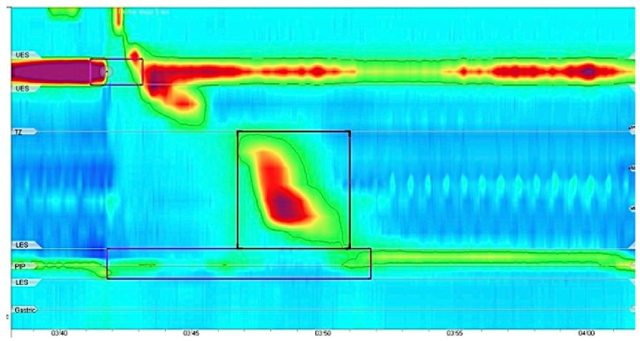
Figure 8. Contractile vigor: normal (450 < DCI < 8000 mmHg·cm·s)

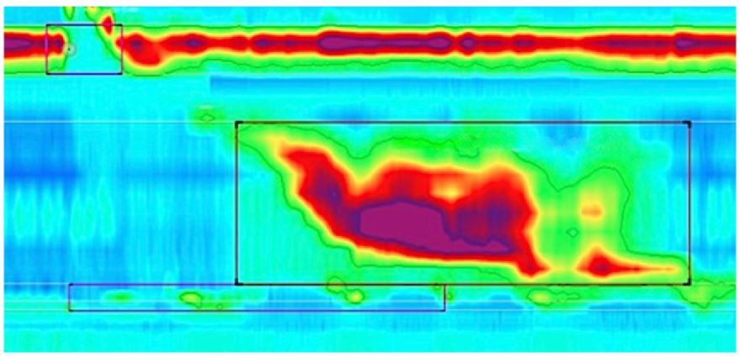
Figure 9. Contractile vigor: hypercontractile (DCI > 8000 mmHg·cm·s)

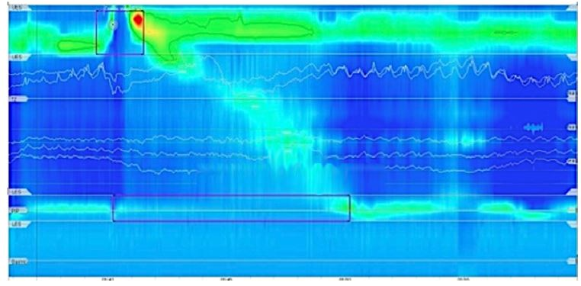
Figure 10. Contractile vigor: failed (DCI < 100 mmHg·cm·s)

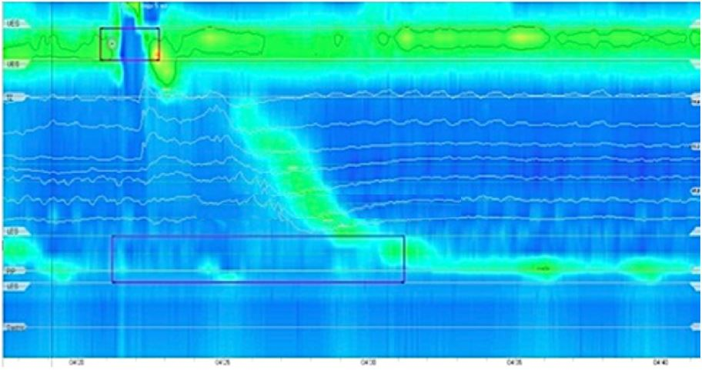
Figure 11. Contractile vigor: weak (100 < DCI < 450 mmHg·cm·s)

If no pathology was found after the analysis of peristaltic contraction vigor, the next stage of the hierarchical analysis, a contraction pattern analysis, began.
Normally, the peristaltic contraction spreads from the UES distad gradually (Figure 12). Starting from the cross-striated muscles of the proximal esophagus (segment S1), passing a transitional zone (TZ) where peristaltic contractions are absent due to the transition of cross-striated muscles into smooth muscles, a contraction reaches the smooth-muscle part of the esophagus (segments S2 and S3). In the distal esophagus contractions decelerate, propagation velocity slows signifying the termination of esophageal peristalsis and the onset of ampullary emptying (segment S4), which is mechanistically very distinct, amounting to the reconstitution of the contracted LES [9].

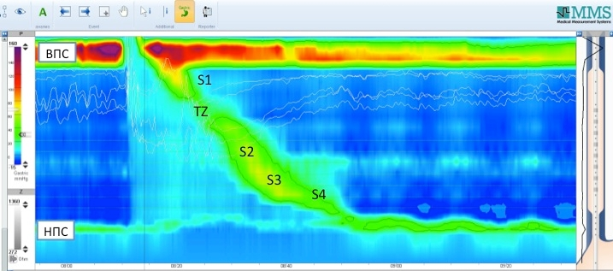
Figure 12. Segments of the esophageal peristaltic wave

However, esophageal contractions do not always follow the described algorithm; sometimes contractions of the smooth muscle part of the esophagus begin prematurely, accompanied by quite severe retrosternal pain, impaired peristalsis of the esophagus, and dysphagia. The emergence of large breaks in the peristaltic wave is another disorder of the contraction pattern which may lead to the impairment of esophageal clearance.
The following parameters are used in analysis of the esophageal contraction pattern (Figure 13): contractile deceleration point (CDP), largest break, and distal latency (DL) [9].

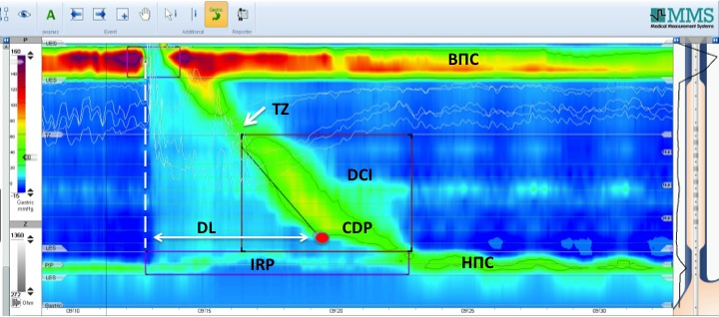
Figure 13. Key metrics of pressure topography plots used to describe peristalsis in the Chicago Classification.
The contractile deceleration point (CDP) - is a key landmark in the assessment of the contraction pattern. On Clouse plots, the CDP represents the inflexion point in the contractile front propagation velocity (Figure 14). CDP indicating the transition from peristalsis to ampullary emptying is localized in the distal esophagus. If it is difficult to find the contractile deceleration point (in the case of an atypical peristaltic wave), the below rule should be followed: CDP must be localized to within 3 cm of the EGJ [9].
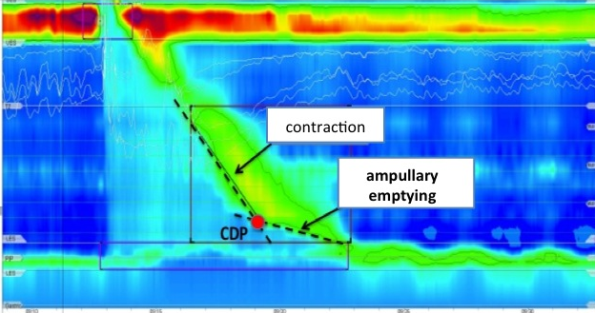
Figure 14. The contractile deceleration point at a 30 mmHg isobar

In the case of ineffective esophageal motility when the vigor of the distal esophagus contractions is reduced, the CDP is measured on a 20 mmHg isobar (Figure 15). In the case of excessively vigorous contractions, the CDP is determined at 50 mmHg. In instances of compartmentalized pressurization the CDP needs to be localized along an isobaric contour line of greater magnitude than the compartmentalized intrabolus pressure (Figure 16) [9].

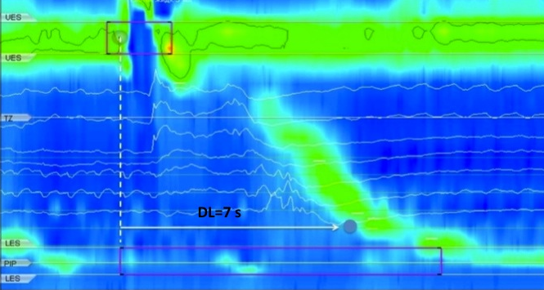
Figure 15. The CDP determination at a 20 mmHg isobar in the case of ineffective esophageal motility

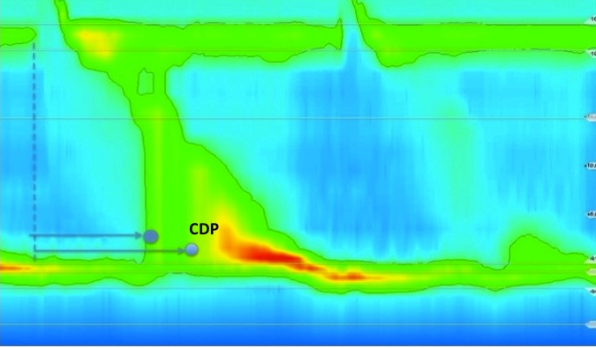
Figure 16. The CDP determination at a 50 mmHg isobar in the case of compartmentalized pressurization

A correct determination of the CDP is crucial, because it permits to calculate the duration of the distal latency (DL).
The distal latency (DL) is measured from upper sphincter relaxation to the contractile deceleration point. Normal DL duration is not less than 4.5 s (Figures 13, 15, 16). This parameter was introduced into the analysis in order to detect premature contractions occurred at the distal esophagospasm or type III achalasia. Pathophysiological explanation of premature contractions states the dysfunction (or death) of inhibitory neurons in the intramural nerve (Auerbach's) plexus [9,12].
The largest break is a zone on the peristaltic wave, where contractions of the muscular esophageal wall are absent or occur with an amplitude of less than 20 mmHg (breaks in the 20-mmHg isobaric contour). Normally, the length of the largest break does not exceed 5 cm (Figures 17 and 19)[9].
In swallows with a normal DCI, the integrity of the peristaltic wave is assessed by measuring the length of axial breaks in the 20-mmHg isobaric contour (largest breaks)[10].
Depending on the DL interval and the largest break, the Chicago Classification v.3 subdivides contractions with normal DCI (450 < DCI < 8000 mmHg x cm × s) into the following contraction patterns [9, 17]:
- Intact: DL > 4.5 s; the largest break is less than 5 cm (Figure 17);
- Premature: DL < 4.5 s (Figure 18);
- Fragmented: Large break (>5 cm length) in the 20-mmHg isobaric contour with DCI >450 mmHg·cm·s (Figure 19).
It should be noted that contractions with DCI < 450 mmHg·cm·s cannot be analysed according to contraction pattern because they are ineffective.

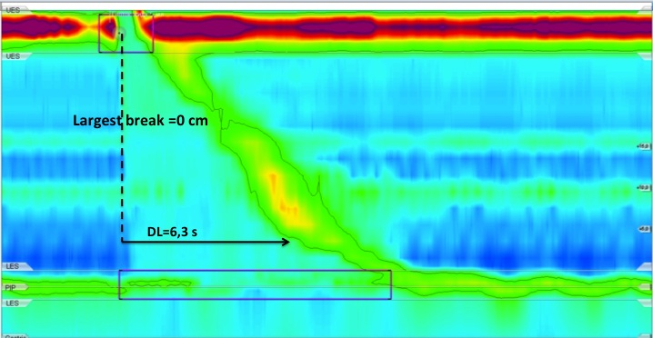
Figure 17. Contraction pattern: intact (DL > 4.5 s, there is no break; 450 < DCI < 8000 mmHg·cm·s)

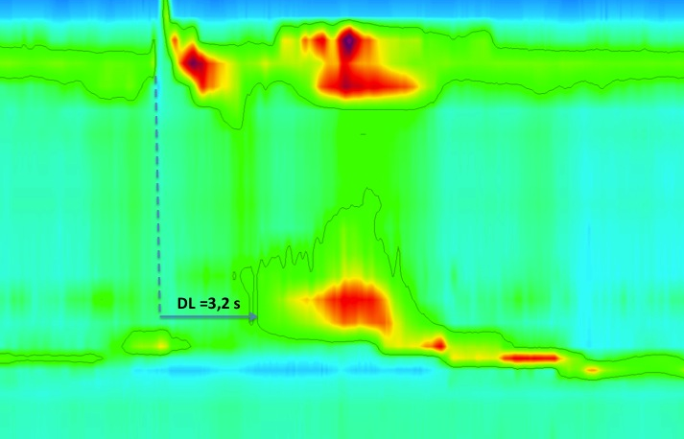
Figure 18. Contraction pattern: premature (DL< 4.5 s; 450 < DCI <8000 mmHg·cm·s)

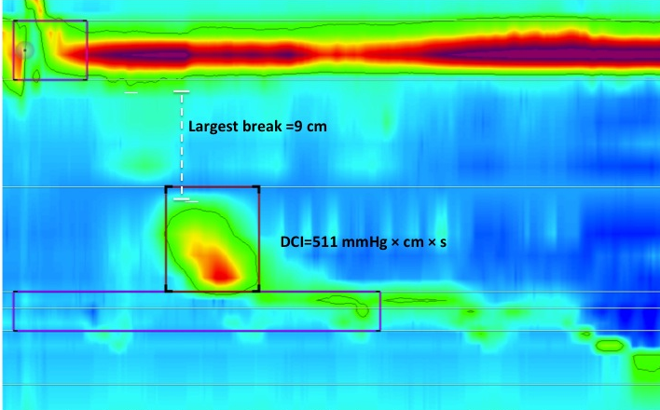
Figure 19. Contraction pattern: fragmented (the largest break is more than 5 cm; 450 < DCI < 8000 mmHg·cm·s)
An assessment of intrabolus pressure is the next stage of analysis. In normal peristalsis of the esophagus, the intrabolus pressure (IBP) should exceed the intragastric one (to ensure normal antegrade propulsion of a food lump), but it should be not more than 30 mmHg.
If bolus transit is impeded by any obstruction and esophageal peristalsis is preserved, the intrabolus pressure rises.
According to the Chicago Classification v.3, there are several types of intrabolus pressure pattern [9, 12]:
- The panesophageal pressurization: an increase in the intrabolus pressure (more than 30 mmHg) extending from the UES to the EGJ. The panesophageal pressurization is most common in the type 2 achalasia (Figure 20);
- Compartmentalized pressurization: pressurization of >30 mmHg extending from the contractile front to the EGJ. These manometric features are observed at a mechanical EGJ obstruction (stricture, hernia) or achalasia onset with the preserved contractile activity of the esophagus (Figure 21);
- EGJ pressurization: pressurization restricted to zone between the LES and CD in conjunction with LES-CD separation in the case of HH (Figure 22);
- Normal: no bolus pressurization >30 mmHg.

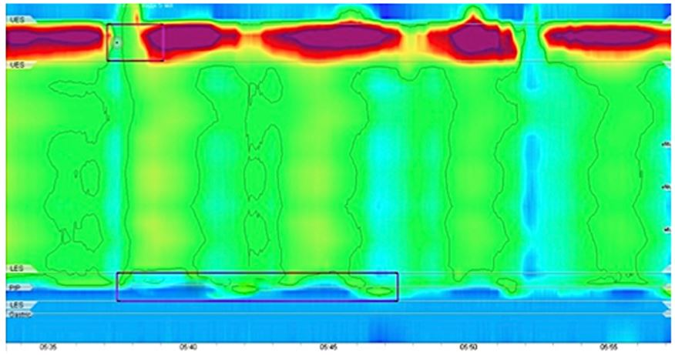
Figure 20. Intrabolus pressure pattern: panesophageal pressurization

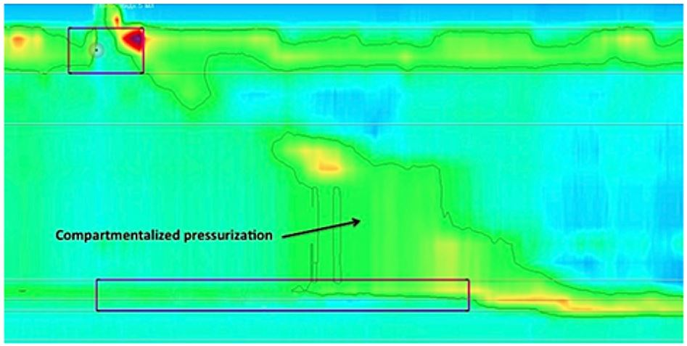
Figure 21. Intrabolus pressure pattern: compartmentalized pressurization

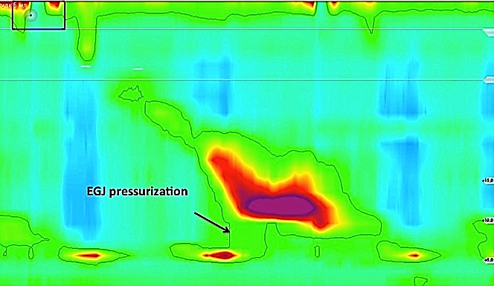
Figure 22. Intrabolus pressure pattern: EGJ pressurization

Based on the information from the individual swallows, a hierarchical categorization of motility disorders is made. First the LES function, and subsequently the esophageal pressure patterns are used to classify the patient and make a diagnosis.

The Chicago Classification: Esophageal Motility Diagnosis

The Chicago Classification subdivides all possible conditions of the esophageal motility into 4 large groups [9]:
- Disorders with EGJ outflow obstruction;
- Major disorders of peristalsis;
- Minor disorders of peristalsis;
- Normal esophageal motility.

Disorders with EGJ outflow obstruction
According to the analysis algorithm recommended by the Chicago Classification, the integrated relaxation pressure (IRP) is the first estimated parameter. Impaired EGJ relaxation with elevation IRP>15mmHg is observed in several types of disorders (Figure 27) united under a common name Disorders with EGJ outflow obstruction [9, 19]:

  - Achalasia
Among primary esophageal motility disorders, achalasia (from a Greek word meaning “lack of relaxation”) is the most important. A degenerative process that selectively affects the excitatory and inhibitory neurons ensuring the contraction and relaxation of the esophageal smooth muscles is the basis of the achalasia pathogenesis. A diagnosis of achalasia requires both impaired deglutitive EGJ relaxation and absent peristalsis. However, absent peristalsis is not synonymous with absent pressurization or contractility.
Depending on pressurization patterns and presence of spastic contractions the Chicago Classification v.3 distinguishes three main types of achalasia [9]:
- Type I achalasia (classic achalasia): elevated median IRP (>15 mmHg), 100% failed peristalsis (DCI <100 mmHg·cm·s) (Figure 23);
- Type II achalasia (with esophageal compression): elevated median IRP (>15 mmHg), 100% failed peristalsis, panesophageal pressurization with ≥20% of swallows (Figure 24);
- Type III achalasia (spastic achalasia): elevated median IRP (>15 mmHg), no normal peristalsis, premature (spastic) contractions with DCI >450 mmHg·cm·s with ≥20% of swallows (Figure 25).
There is a hypothesis that these 3 types of esophageal motility disorders described based on the esophageal manometry findings and observed in patients with achalasia are not three different forms of the disease, but successive stages of achalasia progression. It is believed that at the initial stage of the disease (which occurs with the gradual death of inhibitory motor neurons), motility changes like spastic achalasia (type III) are observed; then, as the excitatory neurons die and the contractile function of the esophagus is depressed, type II achalasia is observed. In case of the total death of motor neurons of the intramural nerve (Auerbach's) plexus, motility changes described as type I achalasia occur accompanied by a significant dilation of the esophagus and its S-shaped deformation [20].

Figure 23. Type I achalasia: impaired EGJ relaxation (IRP ≥15 mmHg), absent peristalsis without marked pressurization or contractions

Figure 24. Type II achalasia: impaired EGJ relaxation (IRP ≥15 mmHg), panesophageal pressurization to >30 mmHg
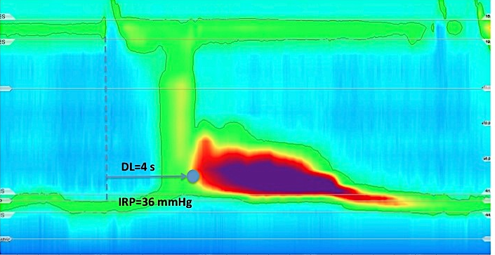
Figure 25. Type III achalasia: impaired EGJ relaxation (IRP ≥15 mmHg), premature (spastic) contractions

Esophagogastric Junction Outflow Obstruction
The conclusion “EGJ outflow obstruction” is made when the HRM findings do not completely meet achalasia criteria: incomplete LES relaxation (IRP > 15 mmHg) combined with preserved peristalsis (Figure 26).

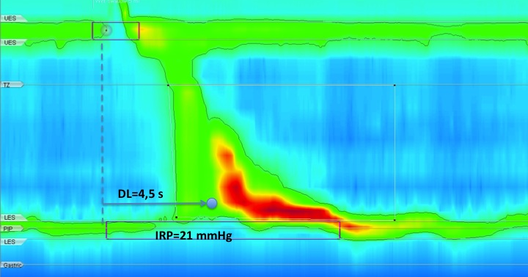
Figure 26. EGJ outflow obstruction: incomplete LES relaxation, preserved peristalsis

It has been reported to be a result of an infiltrative disease, or a variant or incomplete onset of achalasia.

Figure 27. Hierarchical algorithm for the interpretation of HRM studies with CC v3.0: disorders with EGJ outflow obstruction [9]

If the EGJ obstruction is ruled out, the next stage of the hierarchal algorithm begins: assessment of vigor and pattern of peristaltic contractions. In accordance with the Chicago Classification, peristaltic disorders are subdivided into 2 large subgroups [9]:
- Major disorders of peristalsis;
- Minor disorders of peristalsis.

Major disorders of peristalsis
Major disorders of peristalsis are not encountered in control subjects; they are related to significant changes in the distal latency (DL) and distal contractile integral (DCI) with normal values of the integral relaxation pressure (IRP); they occur with obvious clinical symptoms and include the following types (Figure 30)[9]:

- Distal esophageal spasm (DES): normal median IRP, ≥20% premature contractions with DCI >450 mmHg·cm·s. During DES time between the onset of the UES relaxation and the arrival of the peristaltic wave in the distal esophagus is too short (DL<4.5 s). Some normal peristalsis may be present (Figure 18);
- Hypercontractile esophagus: normal median IRP, at least two swallows with DCI >8000 mmHg·cm·s, hypercontractility may involve LES (Figure 28);
- Absent contractility: normal median IRP, 100% failed peristalsis (Figure 29).

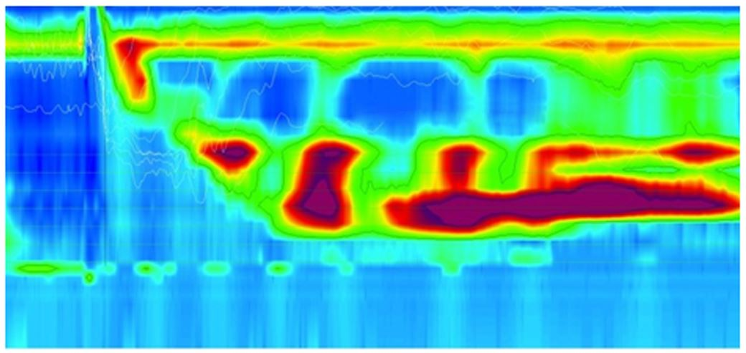
Figure 28. Hypercontractile esophagus: DCI > 8000 mmHg·cm·s

Hypercontractile esophagus usually also have spastic characteristics such as multipeaks, repetitive patterns and short distal latency. A DCI ≥ 8000 mmHg·cm·s was found to be associated with chest pain and dysphagia and with positive response to achalasia treatment.

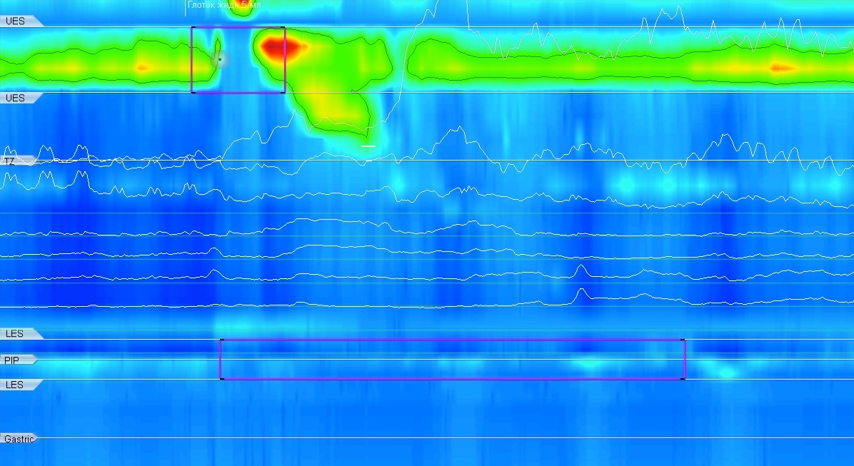
Figure 29. Absent contractility: failed peristalsis

Absent contractility can be seen in patients with systemic sclerosis and predisposes patients to gastroesophageal reflux disease. Absent contractility is clinically important in patients that are considered for fundoplication or gastric bypass surgery. In patients with absent contractility, these surgical interventions are contra-indicated because a higher chance of post-surgical dysphagia is expected.
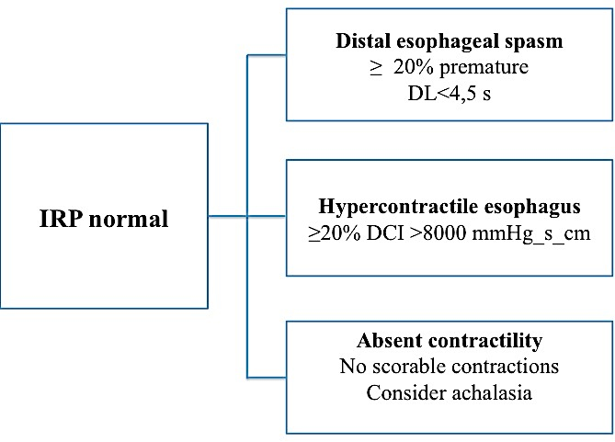
Figure 30. Hierarchical algorithm for the interpretation of HRM studies with CC v3.0: major disorders of peristalsis [9]

Minor disorders of peristalsis

Minor disorders of peristalsis may be found during the HRM in asymptomatic patients as an accidental finding. They are characterized by decreased vigor (DCI < 450 mmHg·cm·s) or disorder of contraction pattern (largest break > 5 cm).
Minor disorders of peristalsis have a clinical relevance for GERD patients, because in most cases they lead to the esophageal clearance disorder. It is believed that minor disorders of peristalsis may serve as predictors of the postoperative dysphagia in case of anti-reflux surgeries [10, 17].
Minor disorders of peristalsis include the following types (Figure 32) [9]:
- Ineffective esophageal motility: ≥50% ineffective (DCI < 450 mmHg·cm·s) swallows with normal IRP mean values (< 15 mmHg) (Figure 31);
- Fragmented peristalsis: ≥50% fragmented swallows (largest break > 5 cm) with normal values of DCI > 450 mmHg·cm·s and IRP < 15 mmHg (Figure 19).

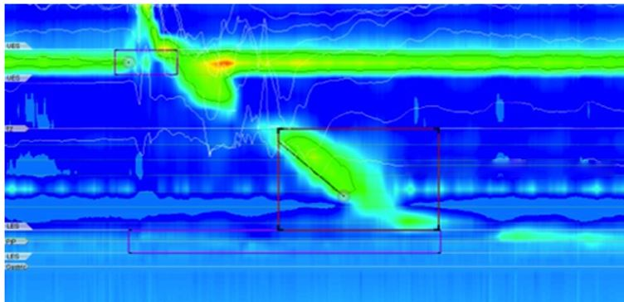
Figure 31. Ineffective esophageal motility in a GERD patient (DCI =326 mmHg·cm·s)

Ineffective esophageal motility often accompanied by a low LES pressure. Ineffective esophageal motility and low LES pressure were found to be more prevalent in patients with gastroesophageal reflux disesase. However, the predictive value of these findings to predict reflux disease is insufficient. As with absent contractility, it is only clinically important in patients in evaluation for antireflux surgery.

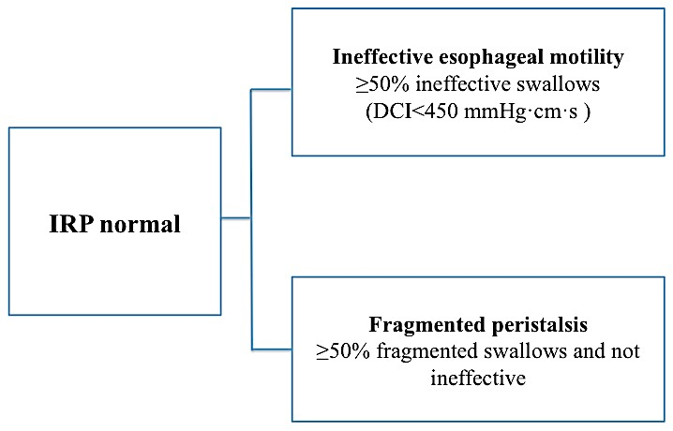

Figure 32. Hierarchical algorithm for the interpretation of HRM studies with CC v3.0: minor disorders of peristalsis [9]

In order to assess the peristaltic capacity in ineffective esophageal motility and fragmented peristalsis, it is recommended to carry out adjunctive tests: the multiple rapid swallow test (MRS), solid bolus swallows, rapid drink challenge test, multiple water swallows and others [13-16].
Multiple rapid swallowing (small volume (5-10ml) ingested in series of 5 swallows) stimulates neural inhibition resulting in abolition of contractions in the esophageal body and complete lower esophageal sphincter relaxation which is followed by peristalsis and LES contraction. It has been suggested that multiple rapid swallowing able to detect abnormalities in inhibitory or excitatory esophageal mechanisms in patients with esophageal symptoms and either normal HRM or ineffective esophageal motility. Healthy subjects had complete inhibition of esophageal body motility during MRS and a strong motor response after MRS, i.e. amplitude of esophageal body contractions in the esophageal body and LES tone being higher than after single swallows (Figure 33) .
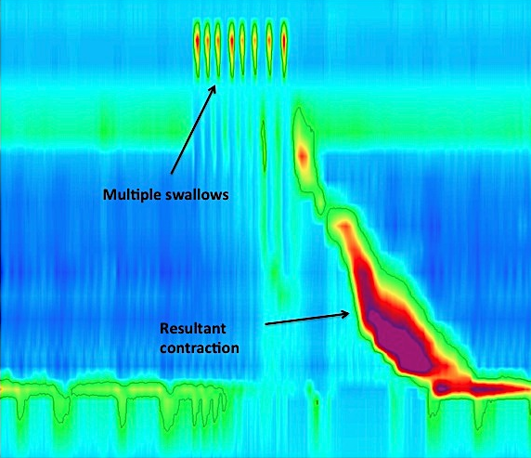
Figure 33. The multiple rapid swallow test, normal values

The absence of strong peristaltic contraction after a series of swallows demonstrates a significant reduction of the peristaltic capacity. Almost 50% patients with ineffective esophageal motility have abnormal MRS, mainly consistent on inability to increase amplitude of esophageal body contraction after MRS (Figure 34) [13-17]. So, WRS test permit to detect impaired peristaltic response in hypotensive dysmotility.

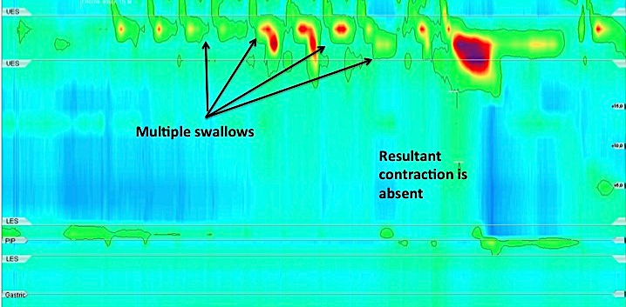
Figure 34. The multiple rapid swallow test in ineffective esophageal motility

The multiple rapid swallow test also permits to identify defective inhibition in hypertensive dysmotility: failure to suppress contractility during repeated swallows (Figure 35) [13-17].

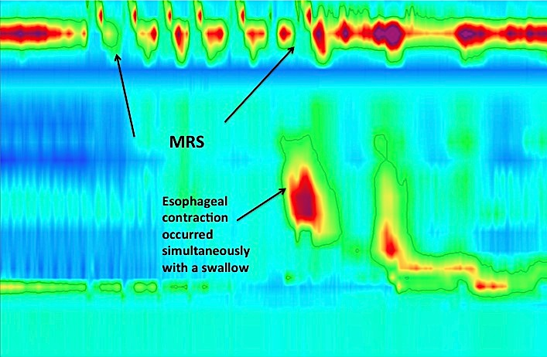
Figure 35. The multiple rapid swallow test: defective inhibition
Normal esophageal motility
A normal esophageal motility (Figure 36) is defined by the following manometric criteria according to the Chicago Classification [9]:
- No EGJ outflow obstruction (IRP is normal);
- More than 50% of swallows are effective (DCI > 450 mmHg·cm·s, largest break < 5 cm);
- The number of abnormal (premature, failed or hypercontractile) contractions does not exceed 20%.

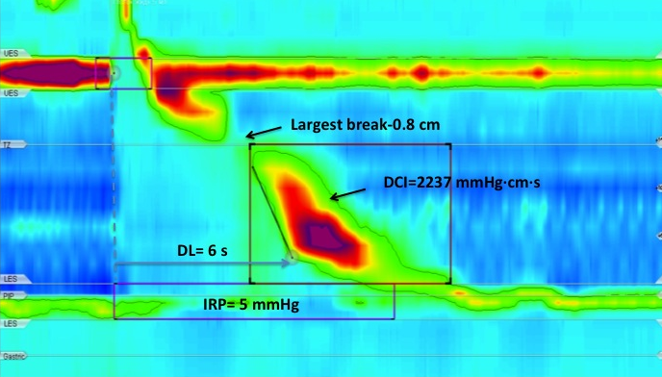
Figure 36. Normal esophageal motility

Data interpretation depending on the device, catheter, and patient’s position during the study
Normal limits of manometric parameters (according to the Chicago Classification) are relatively conventional because they are based on tests carried out using the Sierra Scientific Instruments apparatus with solid-state catheters (4.2 mm in diameter) with 36 sensors positioned not more than 1 cm apart. Values within the range of 5-95 percentile were considered normal [9, 21, 22, 23].
At the same time, the Chicago Classification emphasizes that results of the high-resolution esophageal manometry significantly depend on the apparatus, catheter type (water-perfused, solid-state), its diameter, distance between pressure sensors on the catheter, patient’s weight, age, and race, patient’s position during the study and many other conditions. However, the limits of the Chicago Classification are developed without taking into account the catheter type and do not reflect these differences; in many publications [24, 25,26] dedicated to determination of normal limits in the esophageal manometry, DCI and IRP parameters in the group of healthy volunteers are significantly lower than those of the current Chicago Classification.
In addition, studies comparing manometric parameters obtained in tests using a solid-state or water-perfused catheter demonstrated that whereas DL and DCI values almost do not depend on the catheter type, LES and UES resting pressure values differ significantly when solid-state and water-perfused catheters are used [27, 28, 29,30]. It is related to different diameters of the catheters, a higher record rate and circular location of pressure sensors on the solid-state catheter.
Several studies with water-perfused catheters in patients with verified achalasia demonstrated that IRP > 15 mmHg accepted by the Chicago Classification as the upper limit of normal were not always adequate for water-perfused catheters: in 50% patients with achalasia, the IRP was lower than 15 mmHg [29]. Zavala-Solares et al. [28], Capovilla et al. [25] also confirmed that results of IRP, DCI, and UES resting pressure obtained with a water-perfused catheter was usually lower than similar parameters obtained with a solid-state catheter.
Thus, when using the standards specified in the Chicago Classification, it is necessary to interpret the results obtained using the water-perfusion systems with care (taking into account clinical data and data from other test methods) [18].
When analyzing the esophagus manometry results, the position of the patient during the study is also important. The esophageal manometry standards available today are designed for the supine position. This is due to the fact that the supine position of the patient neutralizes the gravity effects on a bolus transit through the esophagus. In addition, the water-perfused catheters do not allow patient’s vertical position due to the gravity effects on fluid pressure in the catheter capillaries.
At the same time, the vertical position during the study is physiological and minimizes the effects of transfer aortic pulsation on the esophageal manometry (this is especially important in the diagnosis of esophago-gastric junction outflow obstruction) [31]. Several studies have shown that moving a patient to a vertical position often leads to ruling out of the diagnosed “ineffective esophageal motility” obtained in the supine position [32,33]. In a number of studies, it was possible to detect a decrease in DCI, DL, IRP values in the vertical position of patients [33, 34,35]. Today, in many European and US centres, where solid-state catheters are used for diagnostics, patient’s semi-sitting position is most common (with an upper part of the body elevated by 30 degrees) during the study [36].
In the Russian Federation, in accordance with The First Russian Consensus in the High-Resolution Esophageal Manometry adopted on November 11, 2017, it is recommended to study the esophageal motility function in the supine position with the upper body elevated by 15 degrees (to exclude choking over and aspiration during swallowing).
Among researchers involved in the esophageal manometry, the use of various types of bolus (solid, viscous) is also actively discussed to increase the diagnostic value of the study. In the investigations available to date [31, 34, 37] it is shown that a solid bolus leads to a significant increase in DCI, IRP values, which is a kind of a provoking factor that makes it possible to identify esophageal motility disorders more exactly. However, when using a solid and viscous bolus, there are difficulties in standardizing the amount, volume of the bolus, and type of the product used (bread, cracker, marshmallow). In this connection, further studies are required to introduce these techniques into clinical practice.

Conclusion
The high-resolution manometry is a modern tool of functional diagnostics that objectifies the pathogenetic mechanisms of dysphagia, retrosternal pain, heartburn, belching, regurgitation and many other clinical symptoms in such diseases as GERD, achalasia, functional belching, systemic connective tissue diseases, HH, etc. Using data on the esophageal motility and LES characteristics for each individual patient, the gastroenterologist, endoscopist, and surgeon have the opportunity to prescribe the drug therapy correctly, and even to formulate the indications and determine the nature and extent of the surgical treatment.
In addition to great opportunities that this method gives us, there are also unsolved questions: the lack of a clear understanding and classification of UES motility disorders, postoperative peristalsis disorders, changes in the motility due to the drug therapy. The diagnostic value of increased or decreased LES resting pressure and minor disorders of peristalsis found in GERD patients is not completely clear. New diagnostic approaches are to be standardized using provocative tests with swallows of fluid and solid food.
The aforesaid demonstrates great prospects for future scientific and clinical research, discoveries and achievements.

Referenсes
- Bordin D.S., Valitova E.R. Metodika provedenia i klinicheskoe znachenie manometrii pishevoda. M.: Medpraktika-M; 2009. (In Russ.).
- Stef JJ, Dodds WJ, Hogan WJ, Linehan JH, Stewart ET. Intraluminal esophageal manometry: an analysis of variables affecting recording fidelity of peristaltic pressures. Gastroenterology. 1974;67(2):221-230.
- Arndorfer RC, Stef JJ, Dodds WJ, Linehan JH, Hogan WJ. Improved infusion system for intraluminal esophageal manometry. Gastroenterology. 1977;73(1):23-27.
- Dent J. A new technique for continuous sphincter pressure measurement. Gastroenterology. 1976;71(2):263-267.
- Trukhmanov A.S., Storonova O.A. Metodika isuchenia dvigatelnoi funkcii pishevoda. M.: Medpraktika-M; 2011. (In Russ.).
- Сhernyakevich S.A., Babkova I.V., Orlov S.U. Funkcionalnye matody issledovania v hirurgicheskoi gastroentrrologiiMetodika isuchenia dvigatelnoi funkcii pishevoda. M.: Medpraktika-M; 2002. (In Russ.).
- Clouse RE, Staiano A. Topography of the esophageal peristaltic pressure wave. Am J Physiol. 1991; 4:677-684.
- Clouse RE, Staiano A, Alrakawi A, Haroian L. Application of topographical methods to clinical esophageal manometry. Am J Gastroenterol. 2000;95(10):2720-2730.
- Kahrilas PJ, Bredenoord AJ, Fox M, Gyawali CP, Roman S, Smout AJ, Pandolfino JE; International High Resolution Manometry Working Group. The Chicago Classification of esophageal motility disorders, v3.0. Neurogastroenterol Motil. 2015;27(2):160-174. https://doi.org/10.1111/nmo.12477
- Carlson DA, Pandolfino JE. High-Resolution Manometry in Clinical Practice.Gastroenterology & Hepatology. 2015;11(6):374-384.
- Savarino E, Bredenoord AJ, Fox M, Pandolfino JE, Roman S, Gyawali CP; International Working Group for Disorders of Gastrointestinal Motility and Function. Expert consensus document: Advances in the physiological assessment and diagnosis of GERD. Nat Rev Gastroenterol Hepatol. 2017;14(11): 665-676 https://doi.org/10.1038/nrgastro.2017.130
- Kahrilas PJ, Bredenoord AJ, Fox M, Gyawali CP, Roman S, Smout AJPM, Pandolfino JE; International Working Group for Disorders of Gastrointestinal Motility and Function. Expert consensus document: Advances in the management of oesophageal motility disorders in the era of high-resolution manometry: a focus on achalasia syndromes. Nat Rev Gastroenterol Hepatol. 2017;14(11):677-688. https://doi.org/10.1038/nrgastro.2017.132
- Sweis R, Anggiansah A, Wong T, Brady G, Fox M. Assessment of esophageal dysfunction and symptoms during and after a standardized test meal: development and clinical validation of a new methodology utilizing high-resolution manometry. Neurogastroenterol Motil. 2014;26(2):215-228. https://doi.org/10.1111/nmo.12252
- Ang D, Hollenstein M, Misselwitz B, Knowles K, Wright J, Tucker E, Sweis R, Fox M. Rapid Drink Challenge in high-resolution manometry: an adjunctive test for detection of esophageal motility disorders. Neurogastroenterol Motil. 2017;29(1). https://doi.org/10.1111/nmo.12902
- Marin I, Serra J. Patterns of esophageal pressure responses to a rapid drink challenge test in patients with esophageal motility disorders. Neurogastroenterol Motil. 2016;28(4):543-553. https://doi.org/10.1111/nmo.12749
- Elvevi A, Mauro A, Pugliese D, Bravi I, Tenca A, Consonni D, Conte D, Penagini R. Usefulness of low- and high-volume multiple rapid swallowing during high-resolution manometry. Dig Liver Dis. 2015;47(2):103-107. https://doi.org/10.1016/j.dld.2014.10.007
- Gyawali CP, Roman S, Bredenoord AJ, Fox M, Keller J, Pandolfino JE, Sifrim D, Tatum R, Yadlapati R, Savarino E; International GERD Consensus Working Group. Classification of esophageal motor findings in gastro-esophageal reflux disease: Conclusions from an international consensus group. Neurogastroenterol Motil. 2017; 29 (12). https://doi.org/10.1111/nmo.13104
- Herregods TV, Roman S, Kahrilas PJ, Smout AJ, Bredenoord AJ. Normative values in esophageal high-resolution manometry. Neurogastroenterol Motil. 2015;27(2):175-187. ). https://doi.org/10.1111/nmo.12500
- Ponds FA, van Raath MI, Mohamed SMM, Smout AJPM, Bredenoord AJ. Diagnostic features of malignancy-associated pseudoachalasia. Aliment Pharmacol Ther. 2017;45(11):1449-1458 . https://doi.org/10.1111/apt.14057
- Salvador R, Voltarel G, Savarino E, Capovilla G, Pesenti E, Perazzolo A, Nicoletti L, Costantini A, Merigliano S, Costantini M. The natural history of achalasia: Evidence of a continuum-"The evolutive pattern theory". Dig Liver Dis. 2017. https://doi.org/10.1016/j.dld.2017.11.012
- Ghosh SK, Pandolfino JE, Zhang Q, Jarosz A, Shah N, Kahrilas PJ. Quantifying esophageal peristalsis with high-resolution manometry: a study of 75 asymptomatic volunteers. Am J Physiol Gastrointest Liver Physiol. 2006;290(5):988-997.
- Ghosh SK, Pandolfino JE, Rice J, Clarke JO, Kwiatek M, Kahrilas PJ. Impaired deglutitive EGJ relaxation in clinical esophageal manometry: a quantitative analysis of 400 patients and 75 controls. Am J Physiol Gastrointest Liver Physiol. 2007;293(4):878-85.
- Pandolfino JE, Ghosh SK, Rice J, Clarke JO, Kwiatek MA, Kahrilas PJ. Classifying esophageal motility by pressure topography characteristics: a study of 400 patients and 75 controls. Am J Gastroenterol. 2008;103(1):27-37.
- Weijenborg PW, Kessing BF, Smout AJ, Bredenoord AJ. Normal values for solid-state esophageal high-resolution manometry in a European population; an overview of all current metrics. Neurogastroenterol Motil. 2014;26(5):654-9. https://doi.org/10.1111/nmo.12314
- Capovilla G, Savarino E, Costantini M, Nicoletti L, Zaninotto G, Salvador R. Inter-Rater and Inter-Device Agreement For The Diagnosis of Primary Esophageal Motility Disorders based on Chicago Classification Between Solid-State and Water-Perfused HRM System A Prospective, Randomized, Double Blind, Cross- over Study. Digestive Disease Week; 03/05/2014; Chicago, 2014
- Kuribayashi S, Iwakiri K, Kawada A, Kawami N, Hoshino S, Takenouchi N, Hosaka H, Shimoyama Y, Kawamura O, Yamada M, Kusano M. Variant parameter values-as defined by the Chicago Criteria-produced by ManoScan and a new system with Unisensor catheter. Neurogastroenterol Motil. 2015;27(2):188-94. https://doi.org/10.1111/nmo.12446
- Kessing BF, Weijenborg PW, Smout AJ, Hillenius S, Bredenoord AJ. Water-perfused esophageal high-resolution manometry: normal values and validation. Am J Physiol Gastrointest Liver Physiol. 2014;306(6):491-495. https://doi.org/10.1152/ajpgi.00447.2013
- Zavala-Solares MR, Saleme E, Vargas- Vorackova F, Valdovinos MA. Sa1191 high resolution esophageal pressure topography (HREPT) in asymptomatic volunteers. A comparative study between solid-state and water-perfused systems. Gastroenterology 2012; 142:239. https://doi.org/10.1016/s0016-5085(12)60898-1
- Ortiz V, Poppele G, Alonso N, Castellano C, Garrigues V. Evaluation of esophagogastric junction relaxation by 4-second Integrated Relaxation Pressure in achalasia using High Resolution Manometry with water-perfused catheters. Neurogastroenterol Motil. 2014;26(11):1551-1556. https://doi.org/10.1111/nmo.12415
- Bredenoord AJ, Hebbard GS. Technical aspects of clinical high-resolution manometry studies. Neurogastroenterol Motil. 2012;24:5-10. https://doi.org/10.1111/j.1365-2982.2011.01830.x
- Bernhard A, Pohl D, Fried M, Castell DO, Tutuian R. Influence of bolus consistency and position on esophageal high-resolution manometry findings. Dig Dis Sci. 2008;53(5):1198-1205. https://doi.org/10.1007/s10620-007-0014-z
- Xiao Y, Nicodème F, Kahrilas PJ, Roman S, Lin Z, Pandolfino JE. Optimizing the swallow protocol of clinical high-resolution esophageal manometry studies. Neurogastroenterol Motil. 2012;24(10):489-496. https://doi.org/10.1111/j.1365-2982.2012.01989.x
- Roman S, Damon H, Pellissier PE, Mion F. Does body position modify the results of oesophageal high resolution manometry? Neurogastroenterol Motil. 2010;22(3):271-275. https://doi.org/10.1111/j.1365-2982.2009.01416.x
- Sweis R, Anggiansah A, Wong T, Kaufman E, Obrecht S, Fox M. Normative values and inter-observer agreement for liquid and solid bolus swallows in upright and supine positions as assessed by esophageal high-resolution manometry. Neurogastroenterol Motil. 2011;23(6):509-e198. https://doi.org/10.1111/j.1365-2982.2011.01682.x
- Xiao Y, Read A, Nicodème F, Roman S, Kahrilas PJ, Pandolfino JE. The effect of a sitting vs supine posture on normative esophageal pressure topography metrics and Chicago Classification diagnosis of esophageal motility disorders. Neurogastroenterol Motil. 2012;24(10):509-516. https://doi.org/10.1111/j.1365-2982.2012.02001.x
- Niebisch S, Wilshire CL, Peters JH. Systematic analysis of esophageal pressure topography in high-resolution manometry of 68 normal volunteers. Dis Esophagus. 2013;26(7):651-660. https://doi.org/10.1111/dote.12027
- Shi Y, Xiao Y, Peng S, Lin J, Xiong L, Chen M. Normative data of high-resolution impedance manometry in the Chinese population. J Gastroenterol Hepatol. 2013;28(10):1611-1615. https://doi.org/10.1111/jgh.12285

Authors information:
Valeriya Olegovna Kaibysheva, MD, PhD (Cand), senior research fellow at the Research Laboratory of Surgical Gastroenterology and Endoscopy, Pirogov Russian National Research Medical University, gastroenterologist of Municipal Clinical Hospital No. 31, Moscow. Contact information: valeriakai@mail.ru, 42, Lobachevsky str., 119415, Moscow, tel. 8-916-02-06-727

Albert J. Bredenoord, MD, PhD, department of Gastroenterology and Hepatology Academic Medical Center, Meibergdreef 9, 1105 AZ, Amsterdam, the Netherlands Tel: +31 (0)20 566 59 08, Email: a.j.bredenoord@amc.uva.nl
Aleksander Aleksandrovich Smirnov, MD, PhD (Cand), head of the Endoscopy Department, Research Institute of Surgery and Urgent Medicine, Pavlov St Petersburg State Medical University

Evgeniy Dmitrievich Fedorov, MD, PhD, Professor, chief researcher at the Research Laboratory of Surgical Gastroenterology and Endoscopy, Pirogov Russian National Research Medical University. Contact information: efedo@mail.ru, 42, Lobachevskogo str., 119415, Moscow
Evgeniy Leonidovich Nikonov, MD, PhD, Professor, the head of the Gastroenterology Department, Advanced Professional Training Faculty, Pirogov Russian National Research Medical University, the head of Administration and Activities Coordination, the Moscow Healthcare Department, chief editor of the Evidence-Based Gastroenterology Journal, member of the Central Council, Russian Scientific Medical Society of General Practitioners, Moscow

